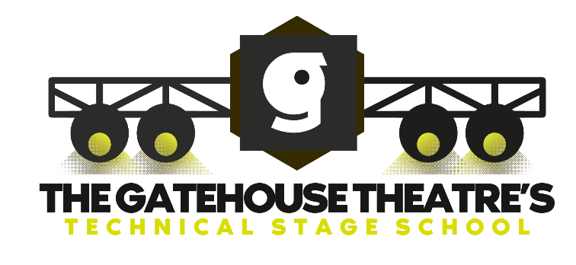

Ever wondered how the magic actually happens once the house lights go down? This year, Stafford Gatehouse Theatre is pulling back the curtain with an exhilarating new Technical Stage School! Running in tandem with our prestigious Summer School production, this is a rare, hands-on opportunity for anyone aged 16–24 to step into the wings and master the art of backstage craft.

From the precision of lighting and sound to the fast-paced world of stage management, you won’t just be watching from the side lines—you’ll be training with the pros. The experience culminates in the ultimate adrenaline rush: running a live show track for the Summer School performances. If you’ve ever wanted to be the driving force behind the scenes, this is your chance to turn your passion into professional skill.

It costs just £450 for this coveted backstage experience and will run over a period of 4 weeks. Starting on 27th July and ending on 22nd August 2026. We have an application form online so if you are interested please fill one out and send it to:

charlotte.homer@freedom-leisure.co.uk
Space is short so we will be holding interviews on Sunday 17th May at the Gatehouse Theatre. We can’t wait to see you there!

